MAD LAB RECORD
Submitted By: Tanisha Mathur
Reg. No.: 230953110
CCE: B, Roll No.: 17
LAB5: INPUT CONTROLS-SPINNERS, PICKERS
Q1. Develop an application named "Vehicle Parking Registration" where the user can register their vehicle for parking. The app should include a spinner that allows users to select the type of vehicle (e.g., car, bike, etc.) and text fields for entering the vehicle number and RC number. Upon clicking the submit button, the entered details should be displayed in a separate view, providing the user with options to either confirm the details or edit them. Once the user confirms the information, a toast message should appear showing a unique serial number to confirm the parking allotment.

activity_main.xml
<?xml version="1.0" encoding="utf-8"?>
<LinearLayout
xmlns:android="http://schemas.android.com/apk/res/android"
android:layout_width="match_parent"
android:layout_height="match_parent"
android:orientation="vertical"
android:padding="20dp">
<TextView
android:layout_width="wrap_content"
android:layout_height="wrap_content"
android:text="Vehicle Parking Registration"
android:textSize="22sp"
android:textStyle="bold"
android:layout_gravity="center"/>
<Spinner
android:id="@+id/spinnerVehicle"
android:layout_width="match_parent"
android:layout_height="wrap_content"
android:layout_marginTop="20dp"/>
<EditText
android:id="@+id/etVehicleNumber"
android:layout_width="match_parent"
android:layout_height="wrap_content"
android:hint="Enter Vehicle Number"
android:layout_marginTop="15dp"/>
<EditText
android:id="@+id/etRCNumber"
android:layout_width="match_parent"
android:layout_height="wrap_content"
android:hint="Enter RC Number"
android:layout_marginTop="15dp"/>
<Button
android:id="@+id/btnSubmit"
android:layout_width="match_parent"
android:layout_height="wrap_content"
android:text="Submit"
android:layout_marginTop="20dp"/>
</LinearLayout>
activity_confirm.xml
<?xml version="1.0" encoding="utf-8"?>
<LinearLayout
xmlns:android="http://schemas.android.com/apk/res/android"
android:layout_width="match_parent"
android:layout_height="match_parent"
android:orientation="vertical"
android:padding="20dp">
<TextView
android:id="@+id/tvDetails"
android:layout_width="match_parent"
android:layout_height="wrap_content"
android:textSize="18sp"/>
<Button
android:id="@+id/btnConfirm"
android:layout_width="match_parent"
android:layout_height="wrap_content"
android:text="Confirm"
android:layout_marginTop="20dp"/>
<Button
android:id="@+id/btnEdit"
android:layout_width="match_parent"
android:layout_height="wrap_content"
android:text="Edit"
android:layout_marginTop="10dp"/>
</LinearLayout>
MainActivity.java
package com.example.a1;
import android.content.Intent;
import android.os.Bundle;
import android.view.View;
import android.widget.*;
import androidx.appcompat.app.AppCompatActivity;
public class MainActivity extends AppCompatActivity {
Spinner spinnerVehicle;
EditText etVehicleNumber, etRCNumber;
Button btnSubmit;
@Override
protected void onCreate(Bundle savedInstanceState) {
super.onCreate(savedInstanceState);
setContentView(R.layout.activity_main);
spinnerVehicle = findViewById(R.id.spinnerVehicle);
etVehicleNumber = findViewById(R.id.etVehicleNumber);
etRCNumber = findViewById(R.id.etRCNumber);
btnSubmit = findViewById(R.id.btnSubmit);
// Vehicle types
String[] vehicleTypes = {"Car", "Bike", "Scooter", "Truck"};
ArrayAdapter<String> adapter = new ArrayAdapter<>(
this,
android.R.layout.simple_spinner_item,
vehicleTypes
);
adapter.setDropDownViewResource(android.R.layout.simple_spinner_dropdown_item);
spinnerVehicle.setAdapter(adapter);
btnSubmit.setOnClickListener(new View.OnClickListener() {
@Override
public void onClick(View v) {
String vehicleType = spinnerVehicle.getSelectedItem().toString();
String vehicleNumber = etVehicleNumber.getText().toString();
String rcNumber = etRCNumber.getText().toString();
if(vehicleNumber.isEmpty() || rcNumber.isEmpty()){
Toast.makeText(MainActivity.this,
"Please enter all details",
Toast.LENGTH_SHORT).show();
}
else{
Intent intent = new Intent(MainActivity.this,
ConfirmActivity.class);
intent.putExtra("type", vehicleType);
intent.putExtra("number", vehicleNumber);
intent.putExtra("rc", rcNumber);
startActivity(intent);
}
}
});
}
}
ConfirmActivity.java
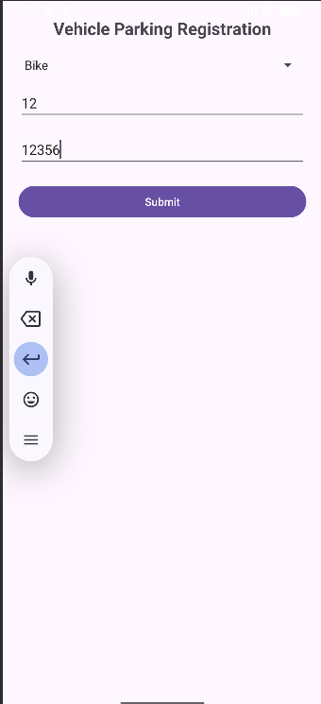
package com.example.a1;
import android.os.Bundle;
import android.widget.*;
import androidx.appcompat.app.AppCompatActivity;
import java.util.Random;
public class ConfirmActivity extends AppCompatActivity {
TextView tvDetails;
Button btnConfirm, btnEdit;
@Override
protected void onCreate(Bundle savedInstanceState) {
super.onCreate(savedInstanceState);
setContentView(R.layout.activity_confirm);
tvDetails = findViewById(R.id.tvDetails);
btnConfirm = findViewById(R.id.btnConfirm);
btnEdit = findViewById(R.id.btnEdit);
String type = getIntent().getStringExtra("type");
String number = getIntent().getStringExtra("number");
String rc = getIntent().getStringExtra("rc");
String details = "Vehicle Type: " + type +
"\nVehicle Number: " + number +
"\nRC Number: " + rc;
tvDetails.setText(details);
btnConfirm.setOnClickListener(v -> {
int serial = new Random().nextInt(10000);
Toast.makeText(ConfirmActivity.this,
"Parking Allotted! Serial No: " + serial,
Toast.LENGTH_LONG).show();
});
btnEdit.setOnClickListener(v -> finish());
}
}
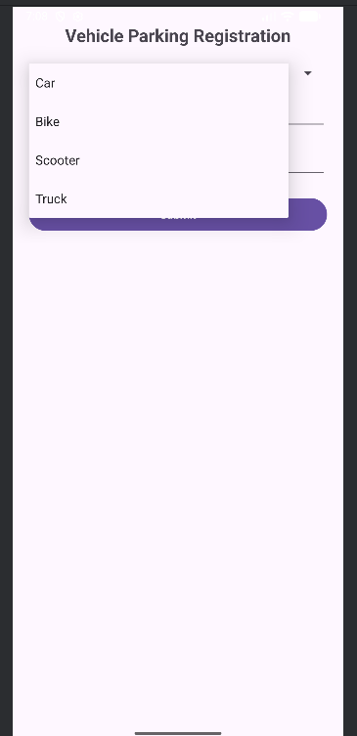
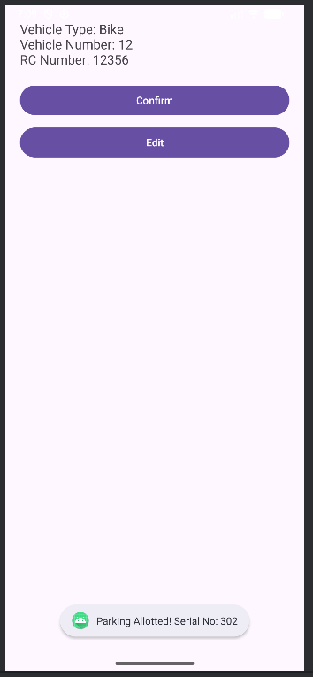

Q2. Design and develop a "Travel Ticket Booking" app where users can book tickets by selecting the source and destination from dropdown lists (spinners) and choosing the date of travel using a date picker. Include a toggle button to let users specify whether they want a one-way ticket or a round-trip ticket. The app should have "Submit" and "Reset" buttons. When the "Submit" button is clicked, display the entered details on a new screen in a structured format. The "Reset" button should clear all input fields and set the date picker to the current system date and time.
activity_main.xml
<?xml version="1.0" encoding="utf-8"?>
<ScrollView
xmlns:android="http://schemas.android.com/apk/res/android"
android:layout_width="match_parent"
android:layout_height="match_parent">
<LinearLayout
android:layout_width="match_parent"
android:layout_height="wrap_content"
android:orientation="vertical"
android:padding="20dp">
<TextView
android:id="@+id/tvTitle"
android:layout_width="wrap_content"
android:layout_height="wrap_content"
android:text="Travel Ticket Booking"
android:textSize="22sp"
android:textStyle="bold"
android:layout_gravity="center"
android:layout_marginBottom="20dp"/>
<Spinner
android:id="@+id/spinnerSource"
android:layout_width="match_parent"
android:layout_height="wrap_content"
android:layout_marginTop="20dp"/>
<Spinner
android:id="@+id/spinnerDestination"
android:layout_width="match_parent"
android:layout_height="wrap_content"
android:layout_marginTop="15dp"/>
<DatePicker
android:id="@+id/datePicker"
android:layout_width="match_parent"
android:layout_height="wrap_content"
android:layout_marginTop="15dp"/>
<ToggleButton
android:id="@+id/toggleTicket"
android:layout_width="wrap_content"
android:layout_height="wrap_content"
android:textOn="Round Trip"
android:textOff="One Way"
android:layout_marginTop="15dp"/>
<Button
android:id="@+id/btnSubmit"
android:layout_width="match_parent"
android:layout_height="wrap_content"
android:text="Submit"
android:layout_marginTop="20dp"/>
<Button
android:id="@+id/btnReset"
android:layout_width="match_parent"
android:layout_height="wrap_content"
android:text="Reset"
android:layout_marginTop="10dp"/>
</LinearLayout>
</ScrollView>
activity_result.xml
<?xml version="1.0" encoding="utf-8"?>
<LinearLayout
xmlns:android="http://schemas.android.com/apk/res/android"
android:layout_width="match_parent"
android:layout_height="match_parent"
android:padding="20dp"
android:orientation="vertical">
<TextView
android:id="@+id/tvResult"
android:layout_width="match_parent"
android:layout_height="wrap_content"
android:textSize="18sp"
android:layout_marginTop="20dp"/>
</LinearLayout>
MainActivity.java
package com.example.a2;
import android.content.Intent;
import android.os.Bundle;
import android.widget.*;
import androidx.appcompat.app.AppCompatActivity;
import java.util.Calendar;
public class MainActivity extends AppCompatActivity {
Spinner spinnerSource, spinnerDestination;
DatePicker datePicker;
ToggleButton toggleTicket;
Button btnSubmit, btnReset;
@Override
protected void onCreate(Bundle savedInstanceState) {
super.onCreate(savedInstanceState);
setContentView(R.layout.activity_main);
spinnerSource = findViewById(R.id.spinnerSource);
spinnerDestination = findViewById(R.id.spinnerDestination);
datePicker = findViewById(R.id.datePicker);
toggleTicket = findViewById(R.id.toggleTicket);
btnSubmit = findViewById(R.id.btnSubmit);
btnReset = findViewById(R.id.btnReset);
String[] cities = {"Delhi", "Mumbai", "Chennai", "Bangalore", "Kolkata"};
ArrayAdapter<String> adapter = new ArrayAdapter<>(
this,
android.R.layout.simple_spinner_item,
cities
);
adapter.setDropDownViewResource(android.R.layout.simple_spinner_dropdown_item);
spinnerSource.setAdapter(adapter);
spinnerDestination.setAdapter(adapter);
// Submit Button
btnSubmit.setOnClickListener(v -> {
String source = spinnerSource.getSelectedItem().toString();
String destination = spinnerDestination.getSelectedItem().toString();
int day = datePicker.getDayOfMonth();
int month = datePicker.getMonth() + 1;
int year = datePicker.getYear();
String date = day + "/" + month + "/" + year;
String ticketType = toggleTicket.isChecked() ?
"Round Trip" : "One Way";
Intent intent = new Intent(MainActivity.this,
ResultActivity.class);
intent.putExtra("source", source);
intent.putExtra("destination", destination);
intent.putExtra("date", date);
intent.putExtra("type", ticketType);
startActivity(intent);
});
// Reset Button
btnReset.setOnClickListener(v -> {
spinnerSource.setSelection(0);
spinnerDestination.setSelection(0);
toggleTicket.setChecked(false);
Calendar calendar = Calendar.getInstance();
datePicker.updateDate(
calendar.get(Calendar.YEAR),
calendar.get(Calendar.MONTH),
calendar.get(Calendar.DAY_OF_MONTH)
);
Toast.makeText(MainActivity.this,
"Fields Reset Successfully",
Toast.LENGTH_SHORT).show();
});
}
}
ResultActivity.java
package com.example.a2;
import android.os.Bundle;
import android.widget.TextView;
import androidx.appcompat.app.AppCompatActivity;
public class ResultActivity extends AppCompatActivity {
TextView tvResult;
@Override
protected void onCreate(Bundle savedInstanceState) {
super.onCreate(savedInstanceState);
setContentView(R.layout.activity_result);
tvResult = findViewById(R.id.tvResult);
String source = getIntent().getStringExtra("source");
String destination = getIntent().getStringExtra("destination");
String date = getIntent().getStringExtra("date");
String type = getIntent().getStringExtra("type");
String details =
"Ticket Details\n\n" +
"Source: " + source + "\n" +
"Destination: " + destination + "\n" +
"Travel Date: " + date + "\n" +
"Ticket Type: " + type;
tvResult.setText(details);
}
}
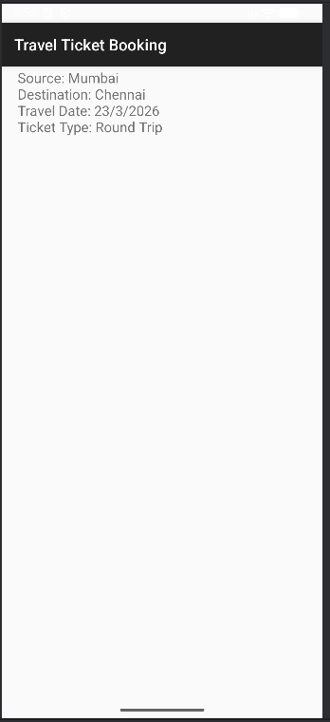
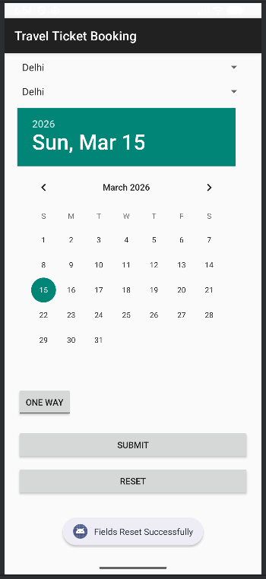

Q3. Design and develop a "Movie Ticket Booking" app where users can book tickets by selecting the movie and theatre from dropdown menus (spinners), the date of the show using a date picker, and the preferred showtime using a time picker. Include a toggle button to let users choose between a standard ticket or a premium ticket. If the "premium" option is selected, ensure the "Submit" button becomes clickable only after 12:00 PM. The app should have "Book Now" and "Reset" buttons. When the user clicks "Book Now," display the entered details along with available seats for the selected show in a new screen in a well-organized format. The "Reset" button should clear all fields and reset the date picker to the current system date. Validate all inputs to ensure correct data entry.
activity_main.xml
<?xml version="1.0" encoding="utf-8"?>
<ScrollView xmlns:android="http://schemas.android.com/apk/res/android"
android:layout_width="match_parent"
android:layout_height="match_parent">
<LinearLayout
android:layout_width="match_parent"
android:layout_height="wrap_content"
android:orientation="vertical"
android:padding="20dp">
<TextView
android:layout_width="wrap_content"
android:layout_height="wrap_content"
android:text="Movie Ticket Booking"
android:textSize="22sp"
android:textStyle="bold"
android:layout_gravity="center"/>
<Spinner
android:id="@+id/spinnerMovie"
android:layout_width="match_parent"
android:layout_height="wrap_content"
android:layout_marginTop="20dp"/>
<Spinner
android:id="@+id/spinnerTheatre"
android:layout_width="match_parent"
android:layout_height="wrap_content"
android:layout_marginTop="15dp"/>
<DatePicker
android:id="@+id/datePicker"
android:layout_width="match_parent"
android:layout_height="wrap_content"/>
<TimePicker
android:id="@+id/timePicker"
android:layout_width="match_parent"
android:layout_height="wrap_content"
android:timePickerMode="spinner"/>
<ToggleButton
android:id="@+id/toggleTicket"
android:layout_width="wrap_content"
android:layout_height="wrap_content"
android:textOn="Premium"
android:textOff="Standard"
android:layout_marginTop="10dp"/>
<Button
android:id="@+id/btnBook"
android:layout_width="match_parent"
android:layout_height="wrap_content"
android:text="Book Now"
android:layout_marginTop="15dp"/>
<Button
android:id="@+id/btnReset"
android:layout_width="match_parent"
android:layout_height="wrap_content"
android:text="Reset"
android:layout_marginTop="10dp"/>
</LinearLayout>
</ScrollView>
activity_result.xml
<?xml version="1.0" encoding="utf-8"?>
<LinearLayout xmlns:android="http://schemas.android.com/apk/res/android"
android:layout_width="match_parent"
android:layout_height="match_parent"
android:padding="20dp"
android:orientation="vertical">
<TextView
android:id="@+id/tvResult"
android:layout_width="match_parent"
android:layout_height="wrap_content"
android:textSize="18sp"/>
</LinearLayout>

MainActivity.java
package com.example.a3;
import android.content.Intent;
import android.os.Bundle;
import android.widget.*;
import androidx.appcompat.app.AppCompatActivity;
import java.util.Calendar;
public class MainActivity extends AppCompatActivity {
Spinner spinnerMovie, spinnerTheatre;
DatePicker datePicker;
TimePicker timePicker;
ToggleButton toggleTicket;
Button btnBook, btnReset;
@Override
protected void onCreate(Bundle savedInstanceState) {
super.onCreate(savedInstanceState);
setContentView(R.layout.activity_main);
spinnerMovie = findViewById(R.id.spinnerMovie);
spinnerTheatre = findViewById(R.id.spinnerTheatre);
datePicker = findViewById(R.id.datePicker);
timePicker = findViewById(R.id.timePicker);
toggleTicket = findViewById(R.id.toggleTicket);
btnBook = findViewById(R.id.btnBook);
btnReset = findViewById(R.id.btnReset);
timePicker.setIs24HourView(false);
String[] movies = {"Select Movie", "Avengers", "Inception", "Interstellar"};
String[] theatres = {"Select Theatre", "PVR", "INOX", "Cinepolis"};
ArrayAdapter<String> movieAdapter = new ArrayAdapter<>(
this,
android.R.layout.simple_spinner_item,
movies
);
movieAdapter.setDropDownViewResource(android.R.layout.simple_spinner_dropdown_item);
spinnerMovie.setAdapter(movieAdapter);
ArrayAdapter<String> theatreAdapter = new ArrayAdapter<>(
this,
android.R.layout.simple_spinner_item,
theatres
);
theatreAdapter.setDropDownViewResource(android.R.layout.simple_spinner_dropdown_item);
spinnerTheatre.setAdapter(theatreAdapter);
btnBook.setOnClickListener(v -> {
if (spinnerMovie.getSelectedItemPosition() == 0 ||
spinnerTheatre.getSelectedItemPosition() == 0) {
Toast.makeText(MainActivity.this,
"Please select Movie and Theatre",
Toast.LENGTH_SHORT).show();
return;
}
String movie = spinnerMovie.getSelectedItem().toString();
String theatre = spinnerTheatre.getSelectedItem().toString();
int day = datePicker.getDayOfMonth();
int month = datePicker.getMonth() + 1;
int year = datePicker.getYear();
int hour = timePicker.getHour();
int minute = timePicker.getMinute();
String date = day + "/" + month + "/" + year;
String time = hour + ":" + minute;
String type = toggleTicket.isChecked() ? "Premium" : "Standard";
Intent intent = new Intent(MainActivity.this, ResultActivity.class);
intent.putExtra("movie", movie);
intent.putExtra("theatre", theatre);
intent.putExtra("date", date);
intent.putExtra("time", time);
intent.putExtra("type", type);
startActivity(intent);
});
btnReset.setOnClickListener(v -> {
spinnerMovie.setSelection(0);
spinnerTheatre.setSelection(0);
toggleTicket.setChecked(false);
Calendar calendar = Calendar.getInstance();
datePicker.updateDate(
calendar.get(Calendar.YEAR),
calendar.get(Calendar.MONTH),
calendar.get(Calendar.DAY_OF_MONTH)
);
Toast.makeText(MainActivity.this,
"Reset Successful",
Toast.LENGTH_SHORT).show();
});
}
}
ResultActivity.java
package com.example.a3;
import android.os.Bundle;
import android.widget.TextView;
import androidx.appcompat.app.AppCompatActivity;
public class ResultActivity extends AppCompatActivity {
@Override
protected void onCreate(Bundle savedInstanceState) {
super.onCreate(savedInstanceState);
setContentView(R.layout.activity_result);
TextView tvResult = findViewById(R.id.tvResult);
String details =
"Booking Details\n\n" +
"Movie: " + getIntent().getStringExtra("movie") + "\n" +
"Theatre: " + getIntent().getStringExtra("theatre") + "\n" +
"Date: " + getIntent().getStringExtra("date") + "\n" +
"Time: " + getIntent().getStringExtra("time") + "\n" +
"Ticket Type: " + getIntent().getStringExtra("type");
tvResult.setText(details);
}
}

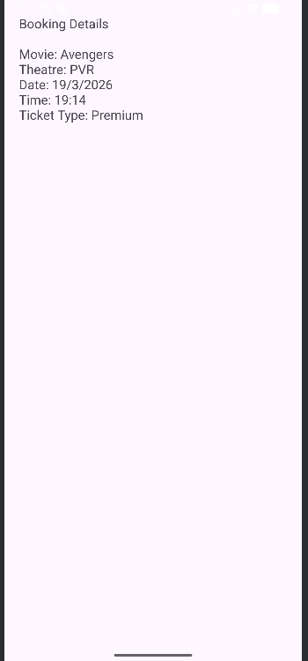
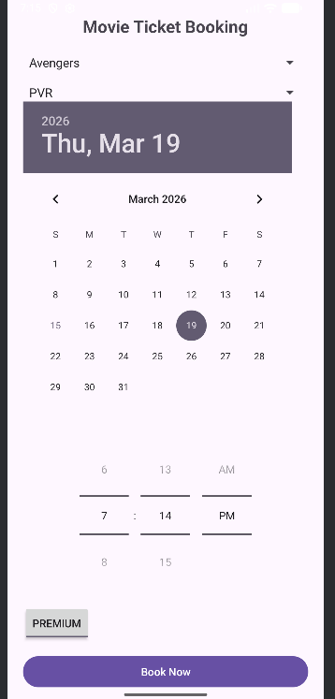

LAB6: INTRODUCTION TO MENU

  - Q1. Design a home page for the "XYZ Fitness Center" using an Options Menu with the following Requirements. Create a simple option menus where in once you click the “menu options”, the option items should get displayed which are "Workout Plans," "Trainers," "Membership". "Workout Plans" should display the list of workout programs (e.g., Weight Loss, Cardio). "Trainers" should display the names and specializations of trainers with their photos. "Membership" should show the membership packages with pricing details.
  - This option menu uses images/icons instead of textual content. This textual content should represent “Contact US”, “About Us”,” Homepage”. Once the user clicks on the corresponding icons it should display corresponding content.

activity_main.xml
<?xml version="1.0" encoding="utf-8"?>
<LinearLayout xmlns:android="http://schemas.android.com/apk/res/android"
android:layout_width="match_parent"
android:layout_height="match_parent"
android:orientation="vertical"
android:gravity="center"
android:padding="20dp">
<TextView
android:text="Welcome to XYZ Fitness Center"
android:textSize="22sp"
android:textStyle="bold"
android:gravity="center"
android:layout_width="wrap_content"
android:layout_height="wrap_content"/>
<TextView
android:text="Use the icons below"
android:layout_marginTop="10dp"
android:layout_width="wrap_content"
android:layout_height="wrap_content"/>
<LinearLayout
android:layout_width="match_parent"
android:layout_height="wrap_content"
android:gravity="center"
android:layout_marginTop="30dp">
<ImageButton
android:id="@+id/btn_home"
android:layout_width="70dp"
android:layout_height="70dp"
android:src="@drawable/ic_home"
android:background="@drawable/icon_bg"
android:tint="@android:color/white"
android:scaleType="centerInside"
android:padding="18dp"/>
<ImageButton
android:id="@+id/btn_about"
android:layout_width="70dp"
android:layout_height="70dp"
android:src="@drawable/ic_about"
android:background="@drawable/icon_bg"
android:tint="@android:color/white"
android:scaleType="centerInside"
android:layout_marginStart="20dp"
android:padding="18dp"/>
<ImageButton
android:id="@+id/btn_contact"
android:layout_width="70dp"
android:layout_height="70dp"
android:src="@drawable/ic_contact"
android:background="@drawable/icon_bg"
android:tint="@android:color/white"
android:scaleType="centerInside"
android:layout_marginStart="20dp"
android:padding="18dp"/>
</LinearLayout>
</LinearLayout>
activity_about.xml
<?xml version="1.0" encoding="utf-8"?>
<ScrollView xmlns:android="http://schemas.android.com/apk/res/android"
android:layout_width="match_parent"
android:layout_height="match_parent"
android:fitsSystemWindows="true"
android:fillViewport="true">
<LinearLayout
android:layout_width="match_parent"
android:layout_height="wrap_content"
android:orientation="vertical"
android:padding="24dp">
<TextView
android:layout_width="match_parent"
android:layout_height="wrap_content"
android:text="About XYZ Fitness Center"
android:textSize="24sp"
android:textStyle="bold"
android:gravity="center"
android:paddingBottom="20dp"/>
<TextView
android:layout_width="match_parent"
android:layout_height="wrap_content"
android:text="At XYZ Fitness Center, we help you achieve your fitness goals with expert trainers and modern facilities."
android:textSize="18sp"
android:lineSpacingExtra="4dp"
android:padding="8dp"/>
</LinearLayout>
</ScrollView>
activity_contact.xml
<?xml version="1.0" encoding="utf-8"?>
<LinearLayout xmlns:android="http://schemas.android.com/apk/res/android"
android:layout_width="match_parent"
android:layout_height="match_parent"
android:padding="20dp"
android:orientation="vertical">
<TextView
android:text="Contact Us"
android:textSize="22sp"
android:textStyle="bold"
android:layout_width="wrap_content"
android:layout_height="wrap_content"/>
<TextView
android:text="\nPhone: +91 9876543210\nEmail: xyzfitness@gmail.com\nAddress: Manipal, India"
android:textSize="18sp"
android:layout_width="wrap_content"
android:layout_height="wrap_content"/>
</LinearLayout>
activity_membership.xml
<?xml version="1.0" encoding="utf-8"?>
<ScrollView xmlns:android="http://schemas.android.com/apk/res/android"
android:layout_width="match_parent"
android:layout_height="match_parent"
android:fillViewport="true">
<LinearLayout
android:layout_width="match_parent"
android:layout_height="wrap_content"
android:orientation="vertical"
android:padding="24dp">
<TextView
android:layout_width="match_parent"
android:layout_height="wrap_content"
android:text="Membership Packages"
android:textSize="24sp"
android:textStyle="bold"
android:gravity="center"
android:paddingBottom="20dp"/>
<TextView
android:layout_width="match_parent"
android:layout_height="wrap_content"
android:text="Basic – ₹2000/month"
android:textSize="18sp"
android:padding="8dp"/>
<TextView
android:layout_width="match_parent"
android:layout_height="wrap_content"
android:text="Standard – ₹3000/month"
android:textSize="18sp"
android:padding="8dp"/>
<TextView
android:layout_width="match_parent"
android:layout_height="wrap_content"
android:text="Premium – ₹4000/month"
android:textSize="18sp"
android:padding="8dp"/>
</LinearLayout>
</ScrollView>

activity_trainers.xml
<?xml version="1.0" encoding="utf-8"?>
<ScrollView xmlns:android="http://schemas.android.com/apk/res/android"
android:layout_width="match_parent"
android:layout_height="match_parent"
android:fillViewport="true">
<LinearLayout
android:layout_width="match_parent"
android:layout_height="wrap_content"
android:orientation="vertical"
android:padding="24dp">
<TextView
android:layout_width="match_parent"
android:layout_height="wrap_content"
android:text="Our Trainers"
android:textSize="24sp"
android:textStyle="bold"
android:gravity="center"
android:paddingBottom="20dp"/>
<TextView
android:layout_width="match_parent"
android:layout_height="wrap_content"
android:text="Rahul – Strength Specialist"
android:textSize="18sp"
android:padding="8dp"/>
<TextView
android:layout_width="match_parent"
android:layout_height="wrap_content"
android:text="Anita – Cardio Expert"
android:textSize="18sp"
android:padding="8dp"/>
</LinearLayout>
</ScrollView>
activity_workout.xml
<?xml version="1.0" encoding="utf-8"?>
<ScrollView xmlns:android="http://schemas.android.com/apk/res/android"
android:layout_width="match_parent"
android:layout_height="match_parent"
android:fillViewport="true">
<LinearLayout
android:layout_width="match_parent"
android:layout_height="wrap_content"
android:orientation="vertical"
android:padding="24dp">
<TextView
android:layout_width="match_parent"
android:layout_height="wrap_content"
android:text="Workout Plans"
android:textSize="24sp"
android:textStyle="bold"
android:gravity="center"
android:paddingBottom="20dp"/>
<TextView
android:layout_width="match_parent"
android:layout_height="wrap_content"
android:text="• Weight Loss Program"
android:textSize="18sp"
android:padding="8dp"/>
<TextView
android:layout_width="match_parent"
android:layout_height="wrap_content"
android:text="• Cardio Training"
android:textSize="18sp"
android:padding="8dp"/>
<TextView
android:layout_width="match_parent"
android:layout_height="wrap_content"
android:text="• Strength Training"
android:textSize="18sp"
android:padding="8dp"/>
<TextView
android:layout_width="match_parent"
android:layout_height="wrap_content"
android:text="• Yoga &amp; Flexibility"
android:textSize="18sp"
android:padding="8dp"/>
</LinearLayout>
</ScrollView>
MainActivity.java
package com.example.a1;
import android.content.Intent;
import android.os.Bundle;
import android.view.Menu;
import android.view.MenuItem;
import android.widget.ImageButton;
import androidx.annotation.NonNull;
import androidx.appcompat.app.AppCompatActivity;
public class MainActivity extends AppCompatActivity {
ImageButton home, about, contact;
@Override
protected void onCreate(Bundle savedInstanceState) {
super.onCreate(savedInstanceState);
setContentView(R.layout.activity_main);
home = findViewById(R.id.btn_home);
about = findViewById(R.id.btn_about);
contact = findViewById(R.id.btn_contact);
home.setOnClickListener(v ->
startActivity(new Intent(MainActivity.this, MainActivity.class)));
about.setOnClickListener(v ->
startActivity(new Intent(MainActivity.this, AboutActivity.class)));
contact.setOnClickListener(v ->
startActivity(new Intent(MainActivity.this, ContactActivity.class)));
}
@Override
public boolean onCreateOptionsMenu(Menu menu) {
getMenuInflater().inflate(R.menu.main_menu, menu);
return true;
}
@Override
public boolean onOptionsItemSelected(@NonNull MenuItem item) {
if (item.getItemId() == R.id.menu_workout) {
startActivity(new Intent(this, WorkoutPlansActivity.class));
}
else if (item.getItemId() == R.id.menu_trainers) {
startActivity(new Intent(this, TrainersActivity.class));
}
else if (item.getItemId() == R.id.menu_membership) {
startActivity(new Intent(this, MembershipActivity.class));
}
return true;
}
}

AboutActivity.java
package com.example.a1;
import android.os.Bundle;
import androidx.appcompat.app.AppCompatActivity;
public class AboutActivity extends AppCompatActivity {
@Override
protected void onCreate(Bundle savedInstanceState) {
super.onCreate(savedInstanceState);
setContentView(R.layout.activity_about);
}
@Override
public boolean onSupportNavigateUp() {
finish();
return true;
}
}
ContactActivity.java
package com.example.a1;
import android.os.Bundle;
import androidx.appcompat.app.AppCompatActivity;
public class ContactActivity extends AppCompatActivity {
@Override
protected void onCreate(Bundle savedInstanceState) {
super.onCreate(savedInstanceState);
setContentView(R.layout.activity_contact);
}
@Override
public boolean onSupportNavigateUp() {
finish();
return true;
}
}
MembershipActivity.java
package com.example.a1;
import android.os.Bundle;
import androidx.appcompat.app.AppCompatActivity;
public class MembershipActivity extends AppCompatActivity {
@Override
protected void onCreate(Bundle savedInstanceState) {
super.onCreate(savedInstanceState);
setContentView(R.layout.activity_membership);
}
@Override
public boolean onSupportNavigateUp() {
finish();
return true;
}
}
TrainersActivity.java
package com.example.a1;
import android.os.Bundle;
import androidx.appcompat.app.AppCompatActivity;
public class TrainersActivity extends AppCompatActivity {
@Override
protected void onCreate(Bundle savedInstanceState) {
super.onCreate(savedInstanceState);
setContentView(R.layout.activity_trainers);
}
@Override
public boolean onSupportNavigateUp() {
finish();
return true;
}
}
WorkoutPlansActivity.java
package com.example.a1;
import android.os.Bundle;
import androidx.appcompat.app.AppCompatActivity;
public class WorkoutPlansActivity extends AppCompatActivity {
@Override
protected void onCreate(Bundle savedInstanceState) {
super.onCreate(savedInstanceState);
setContentView(R.layout.activity_workout);
getSupportActionBar().setDisplayHomeAsUpEnabled(true);
}
}
main_menu.xml
<?xml version="1.0" encoding="utf-8"?>
<menu xmlns:android="http://schemas.android.com/apk/res/android">
<item
android:id="@+id/menu_workout"
android:title="Workout Plans"/>
<item
android:id="@+id/menu_trainers"
android:title="Trainers"/>
<item
android:id="@+id/menu_membership"
android:title="Membership"/>
</menu>
icon_bg.xml
<shape xmlns:android="http://schemas.android.com/apk/res/android">
<solid android:color="#4CAF50"/>
<size android:width="70dp" android:height="70dp"/>
<corners android:radius="35dp"/>
</shape>
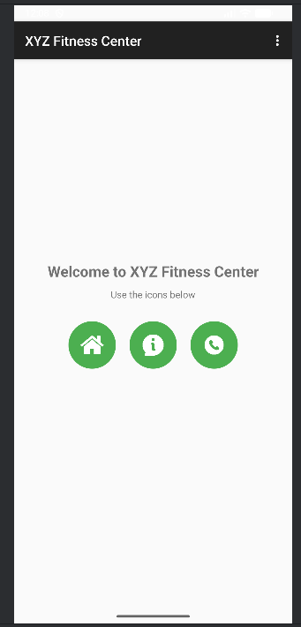
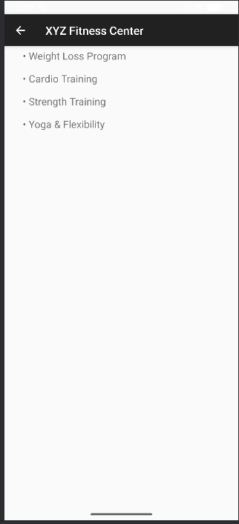
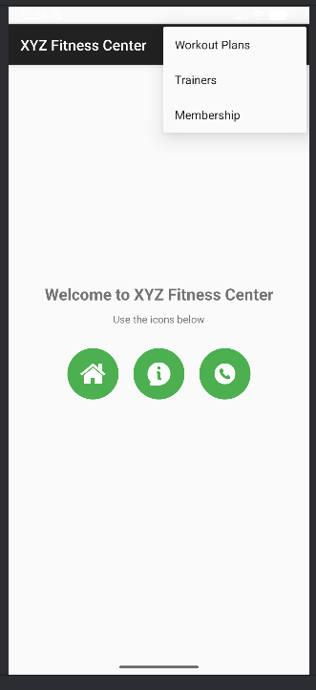
LAB7: CREATING CONTEXTUAL AND POP-UP MENUS

Q1. Design and develop an application that displays a list of installed applications on your device. On long press of any application, display the following options: a) Show whether the application is a system app or user-installed. b) Provide options to open the app, uninstall it, or view its details (e.g., version, storage usage). c) Indicate whether the app has special permissions enabled, like location or camera access.
When an option like "View Details" is selected, navigate to a detailed view showing the app's permissions, size, and version. For the "Uninstall" option, prompt the user for confirmation before proceeding.

activity_main.xml
<LinearLayout xmlns:android="http://schemas.android.com/apk/res/android"
android:layout_width="match_parent"
android:layout_height="match_parent"
android:orientation="vertical">
<TextView
android:layout_width="match_parent"
android:layout_height="wrap_content"
android:text="Installed Applications"
android:textSize="20sp"
android:gravity="center"
android:padding="10dp"
android:textStyle="bold"
android:layout_marginBottom="40dp"/>
<ListView
android:id="@+id/listViewApps"
android:layout_width="match_parent"
android:layout_height="0dp"
android:layout_weight="1"/>
</LinearLayout>

activity_app_details.xml
<ScrollView xmlns:android="http://schemas.android.com/apk/res/android"
android:layout_width="match_parent"
android:layout_height="match_parent">
<LinearLayout
android:orientation="vertical"
android:padding="16dp"
android:layout_width="match_parent"
android:layout_height="wrap_content">
<TextView
android:id="@+id/tvDetails"
android:layout_width="match_parent"
android:layout_height="wrap_content"
android:textSize="16sp"/>
</LinearLayout>
</ScrollView>

MainActivity.java
package com.example.a1;
import android.app.AlertDialog;
import android.content.Intent;
import android.content.pm.ApplicationInfo;
import android.content.pm.PackageInfo;
import android.content.pm.PackageManager;
import android.net.Uri;
import android.os.Bundle;
import android.view.ContextMenu;
import android.view.MenuItem;
import android.view.View;
import android.widget.AdapterView;
import android.widget.ArrayAdapter;
import android.widget.ListView;
import android.widget.Toast;
import androidx.appcompat.app.AppCompatActivity;
import java.util.ArrayList;
import java.util.List;
public class MainActivity extends AppCompatActivity {
ListView listView;
PackageManager packageManager;
List<ApplicationInfo> appList;
ArrayList<String> appNames;
@Override
protected void onCreate(Bundle savedInstanceState) {
super.onCreate(savedInstanceState);
setContentView(R.layout.activity_main);
listView = findViewById(R.id.listViewApps);
packageManager = getPackageManager();
// Get installed applications
appList = packageManager.getInstalledApplications(PackageManager.GET_META_DATA);
appNames = new ArrayList<>();
for (ApplicationInfo app : appList) {
appNames.add(packageManager.getApplicationLabel(app).toString());
}
ArrayAdapter<String> adapter = new ArrayAdapter<>(
this,
android.R.layout.simple_list_item_1,
appNames
);
listView.setAdapter(adapter);
// Register context menu
registerForContextMenu(listView);
}
// Create Context Menu
@Override
public void onCreateContextMenu(ContextMenu menu, View v,
ContextMenu.ContextMenuInfo menuInfo) {
super.onCreateContextMenu(menu, v, menuInfo);
menu.setHeaderTitle("App Options");
menu.add(0, 1, 0, "System or User App");
menu.add(0, 2, 0, "Open App");
menu.add(0, 3, 0, "Uninstall App");
menu.add(0, 4, 0, "View Details");
menu.add(0, 5, 0, "Check Special Permissions");
}
// Handle Context Menu Click
@Override
public boolean onContextItemSelected(MenuItem item) {
AdapterView.AdapterContextMenuInfo info =
(AdapterView.AdapterContextMenuInfo) item.getMenuInfo();
ApplicationInfo selectedApp = appList.get(info.position);
switch (item.getItemId()) {
case 1:
boolean isSystem =
(selectedApp.flags & ApplicationInfo.FLAG_SYSTEM) != 0;
Toast.makeText(this,
isSystem ? "System App" : "User Installed App",
Toast.LENGTH_LONG).show();
return true;
case 2:
Intent launchIntent =
packageManager.getLaunchIntentForPackage(selectedApp.packageName);
if (launchIntent != null)
startActivity(launchIntent);
return true;
case 3:
new AlertDialog.Builder(this)
.setTitle("Confirm Uninstall")
.setMessage("Are you sure you want to uninstall this app?")
.setPositiveButton("Yes", (dialog, which) -> {
Intent intent = new Intent(Intent.ACTION_DELETE);
intent.setData(Uri.parse("package:" + selectedApp.packageName));
startActivity(intent);
})
.setNegativeButton("No", null)
.show();
return true;
case 4:
Intent detailsIntent =
new Intent(this, AppDetailsActivity.class);
detailsIntent.putExtra("packageName", selectedApp.packageName);
startActivity(detailsIntent);
return true;
case 5:
checkPermissions(selectedApp.packageName);
return true;
}
return super.onContextItemSelected(item);
}
// Check Camera & Location Permission
private void checkPermissions(String packageName) {
try {
PackageInfo info = packageManager.getPackageInfo(
packageName,
PackageManager.GET_PERMISSIONS);
String[] permissions = info.requestedPermissions;
boolean camera = false;
boolean location = false;
if (permissions != null) {
for (String perm : permissions) {
if (perm.contains("CAMERA")) camera = true;
if (perm.contains("LOCATION")) location = true;
}
}
Toast.makeText(this,
"Camera Permission: " + camera +
"\nLocation Permission: " + location,
Toast.LENGTH_LONG).show();
} catch (Exception e) {
e.printStackTrace();
}
}
}

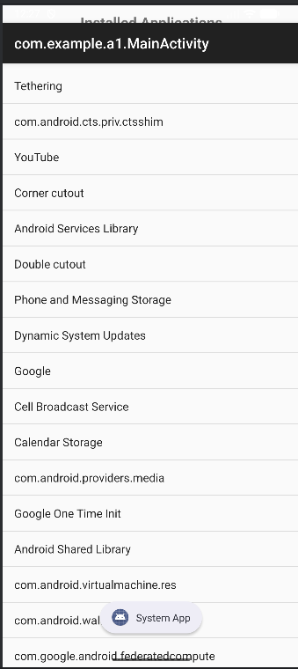
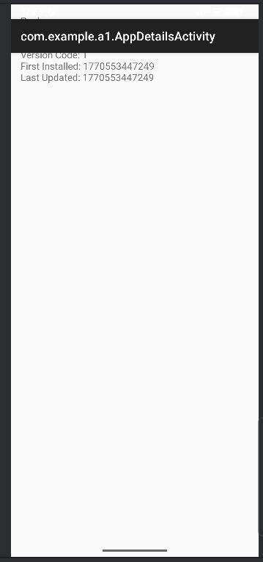
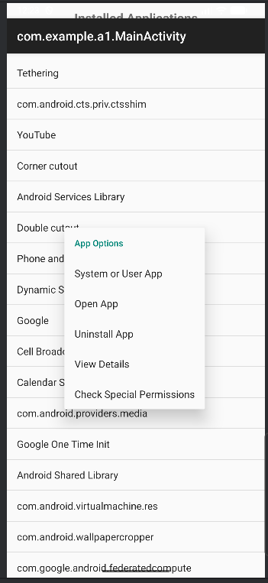
AppDetailsActivity.java
package com.example.a1;
import android.content.pm.PackageInfo;
import android.content.pm.PackageManager;
import android.os.Bundle;
import android.widget.TextView;
import androidx.appcompat.app.AppCompatActivity;
public class AppDetailsActivity extends AppCompatActivity {
TextView tvDetails;
@Override
protected void onCreate(Bundle savedInstanceState) {
super.onCreate(savedInstanceState);
setContentView(R.layout.activity_app_details);
tvDetails = findViewById(R.id.tvDetails);
String packageName = getIntent().getStringExtra("packageName");
try {
PackageManager pm = getPackageManager();
PackageInfo info = pm.getPackageInfo(packageName, 0);
String details =
"Package: " + packageName +
"\nVersion: " + info.versionName +
"\nVersion Code: " + info.versionCode +
"\nFirst Installed: " + info.firstInstallTime +
"\nLast Updated: " + info.lastUpdateTime;
tvDetails.setText(details);
} catch (Exception e) {
e.printStackTrace();
}
}
}
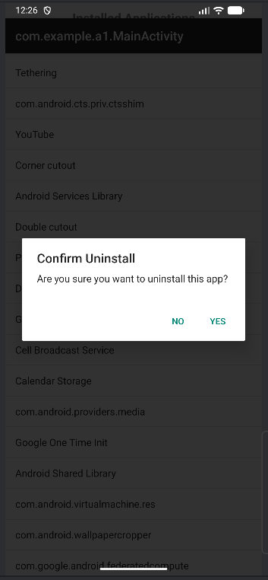
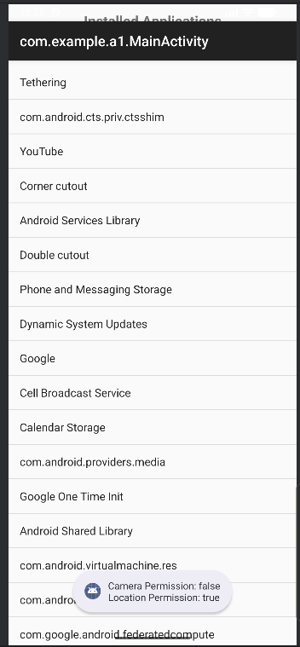

Q2. Create a View with the name “My Menu ” which contains an image as an icon.On click of that icon it shows a submenu as ”Image -1”,”Image -2” .On click of each item that particular image should be displayed with the corresponding content in the Toast.
activity_main.xml
<?xml version="1.0" encoding="utf-8"?>
<LinearLayout
xmlns:android="http://schemas.android.com/apk/res/android"
android:layout_width="match_parent"
android:layout_height="match_parent"
android:gravity="center"
android:orientation="vertical">
<Button
android:id="@+id/btnMenu"
android:layout_width="wrap_content"
android:layout_height="wrap_content"
android:text="My Menu" />
<ImageView
android:id="@+id/imageView"
android:layout_width="250dp"
android:layout_height="250dp"
android:layout_marginTop="20dp"
android:scaleType="centerCrop"/>
</LinearLayout>
MainActivity.java
package com.example.a2;
import android.os.Bundle;
import android.view.View;
import android.widget.Button;
import android.widget.ImageView;
import android.widget.PopupMenu;
import android.widget.Toast;
import androidx.appcompat.app.AppCompatActivity;
public class MainActivity extends AppCompatActivity {
Button btnMenu;
ImageView imageView;
@Override
protected void onCreate(Bundle savedInstanceState) {
super.onCreate(savedInstanceState);
setContentView(R.layout.activity_main);
btnMenu = findViewById(R.id.btnMenu);
imageView = findViewById(R.id.imageView);
btnMenu.setOnClickListener(v -> {
PopupMenu popupMenu = new PopupMenu(MainActivity.this, btnMenu);
popupMenu.getMenuInflater().inflate(R.menu.popup_menu, popupMenu.getMenu());
popupMenu.setOnMenuItemClickListener(item -> {
if (item.getItemId() == R.id.image1) {
imageView.setImageResource(R.drawable.image1);
Toast.makeText(MainActivity.this, "Image -1 Selected", Toast.LENGTH_SHORT).show();
return true;
}
if (item.getItemId() == R.id.image2) {
imageView.setImageResource(R.drawable.image2);
Toast.makeText(MainActivity.this, "Image -2 Selected", Toast.LENGTH_SHORT).show();
return true;
}
return false;
});
popupMenu.show();
});
}
}
popup_menu.xml
<?xml version="1.0" encoding="utf-8"?>
<menu xmlns:android="http://schemas.android.com/apk/res/android">
<item
android:id="@+id/image1"
android:title="Image -1" />
<item
android:id="@+id/image2"
android:title="Image -2" />
</menu>

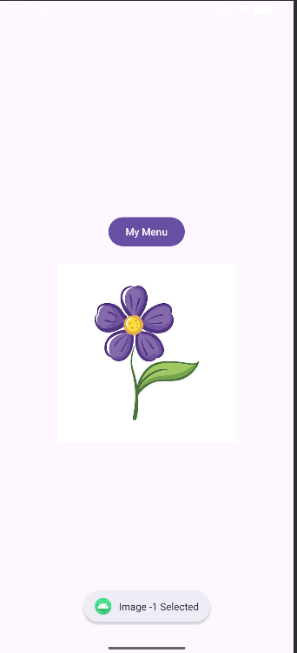
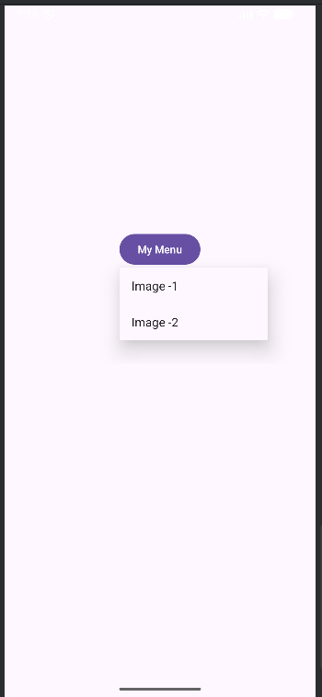
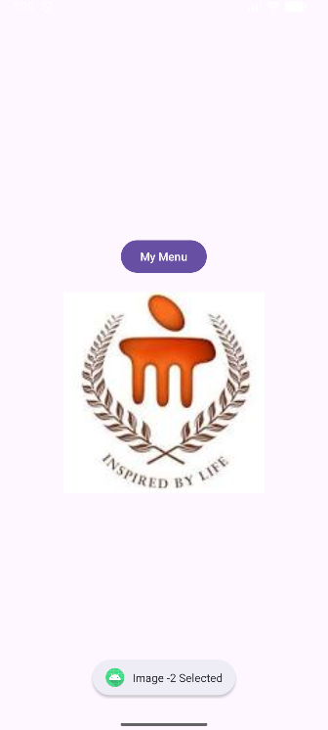

  - Q3. Create a view that displays textual content providing a description of "Digital Transformation". Add a filter option with submenus: "Search Keywords" - Allow the user to input keywords that can be searched within the content.
  - "Highlight" - Highlight specific words or phrases provided by the user in the document.
  - "Sort" - Provide an option to sort the entire content either alphabetically or by relevance to the search keywords.
activity_main.xml
<?xml version="1.0" encoding="utf-8"?>
<LinearLayout
xmlns:android="http://schemas.android.com/apk/res/android"
android:layout_width="match_parent"
android:layout_height="match_parent"
android:orientation="vertical"
android:padding="16dp">
<Button
android:id="@+id/btnFilter"
android:layout_width="wrap_content"
android:layout_height="wrap_content"
android:text="Filter Options"/>
<ScrollView
android:layout_width="match_parent"
android:layout_height="match_parent">
<TextView
android:id="@+id/textViewContent"
android:layout_width="match_parent"
android:layout_height="wrap_content"
android:textSize="16sp"
android:paddingTop="16dp"/>

</ScrollView>

</LinearLayout>
MainActivity.java
package com.example.a3;
import android.app.AlertDialog;
import android.os.Bundle;
import android.text.SpannableString;
import android.text.Spanned;
import android.text.style.BackgroundColorSpan;
import android.widget.Button;
import android.widget.EditText;
import android.widget.PopupMenu;
import android.widget.TextView;
import android.widget.Toast;
import androidx.appcompat.app.AppCompatActivity;
import java.util.Arrays;
import java.util.Collections;
import java.util.List;
public class MainActivity extends AppCompatActivity {
TextView textView;
Button btnFilter;
String content = "Digital Transformation refers to the integration of digital technology " +
"into all areas of business and society. It changes how organizations operate and deliver value. " +
"It includes cloud computing, artificial intelligence, big data, and automation. " +
"Digital transformation enhances efficiency, innovation, and customer experience.";
String currentKeyword = "";
@Override
protected void onCreate(Bundle savedInstanceState) {
super.onCreate(savedInstanceState);
setContentView(R.layout.activity_main);
textView = findViewById(R.id.textViewContent);
btnFilter = findViewById(R.id.btnFilter);
textView.setText(content);
btnFilter.setOnClickListener(v -> {
PopupMenu popupMenu = new PopupMenu(MainActivity.this, btnFilter);
popupMenu.getMenuInflater().inflate(R.menu.filter_popup, popupMenu.getMenu());
popupMenu.setOnMenuItemClickListener(item -> {
if (item.getItemId() == R.id.search) {
showSearchDialog();
return true;
}
if (item.getItemId() == R.id.highlight) {
highlightKeyword();
return true;
}
if (item.getItemId() == R.id.sort_alpha) {
sortAlphabetically();
return true;
}
if (item.getItemId() == R.id.sort_relevance) {
sortByRelevance();
return true;
}
return false;
});
popupMenu.show();
});
}
private void showSearchDialog() {
EditText input = new EditText(this);
new AlertDialog.Builder(this)
.setTitle("Enter Keyword")
.setView(input)
.setPositiveButton("Search", (dialog, which) -> {
currentKeyword = input.getText().toString();
if (content.toLowerCase().contains(currentKeyword.toLowerCase())) {
Toast.makeText(this, "Keyword Found!", Toast.LENGTH_SHORT).show();
} else {
Toast.makeText(this, "Keyword Not Found!", Toast.LENGTH_SHORT).show();
}
})
.setNegativeButton("Cancel", null)
.show();
}
private void highlightKeyword() {
if (currentKeyword.isEmpty()) {
Toast.makeText(this, "Search first!", Toast.LENGTH_SHORT).show();
return;
}
SpannableString spannable = new SpannableString(content);
int index = content.toLowerCase().indexOf(currentKeyword.toLowerCase());
if (index >= 0) {
spannable.setSpan(
new BackgroundColorSpan(0xFFFFFF00),
index,
index + currentKeyword.length(),
Spanned.SPAN_EXCLUSIVE_EXCLUSIVE
);
textView.setText(spannable);
}
}
private void sortAlphabetically() {
List<String> words = Arrays.asList(content.split(" "));
Collections.sort(words);
textView.setText(String.join(" ", words));
}
private void sortByRelevance() {
if (currentKeyword.isEmpty()) {
Toast.makeText(this, "Search first!", Toast.LENGTH_SHORT).show();
return;
}
List<String> words = Arrays.asList(content.split(" "));
Collections.sort(words, (w1, w2) -> {
boolean w1Match = w1.toLowerCase().contains(currentKeyword.toLowerCase());
boolean w2Match = w2.toLowerCase().contains(currentKeyword.toLowerCase());
if (w1Match && !w2Match) return -1;
if (!w1Match && w2Match) return 1;
return w1.compareTo(w2);
});
textView.setText(String.join(" ", words));
}
}

Menu-> filter_popup.xml
<?xml version="1.0" encoding="utf-8"?>
<menu xmlns:android="http://schemas.android.com/apk/res/android">
<item
android:id="@+id/search"
android:title="Search Keywords"/>
<item
android:id="@+id/highlight"
android:title="Highlight"/>
<item
android:id="@+id/sort_alpha"
android:title="Sort Alphabetically"/>
<item
android:id="@+id/sort_relevance"
android:title="Sort by Relevance"/>
</menu>
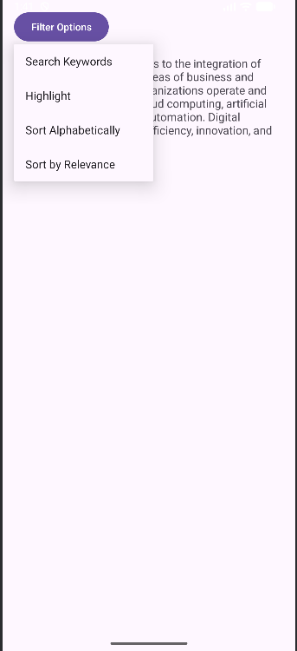
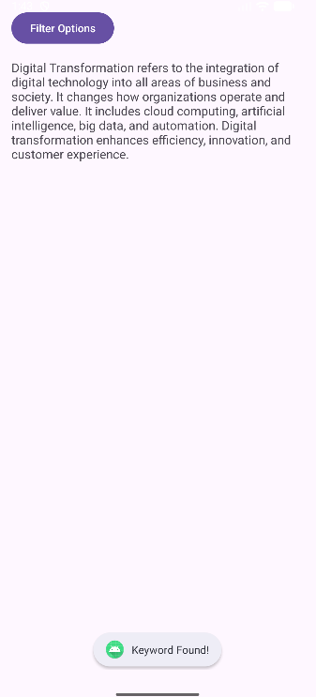
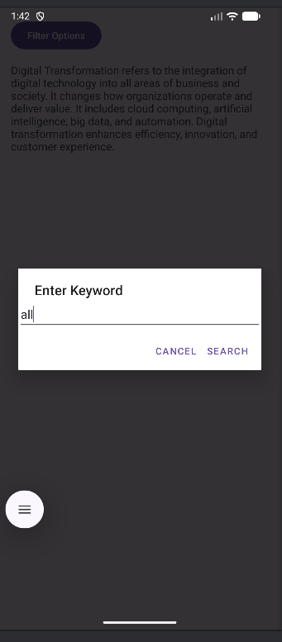
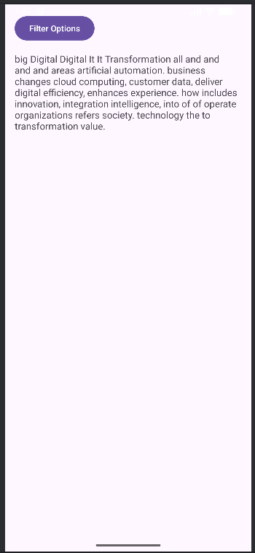

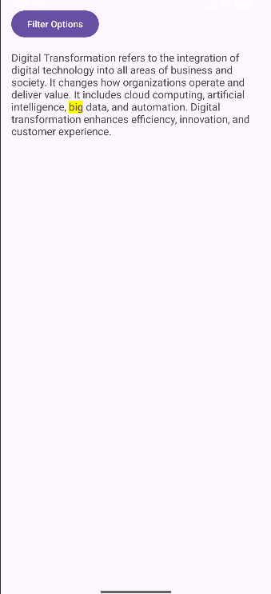

LAB8: ANDROID SQLITE & SHARED PREFERENCES

Q1. Write a program to create a "Task Manager" application with the following features:
a) A form to create and save tasks with fields like task name, due date, and priority level (High, Medium, Low).
b) A list view to display all the saved tasks with their details.
c) An option to edit or delete any task from the list.
activity_main.xml
<LinearLayout xmlns:android="http://schemas.android.com/apk/res/android"
android:orientation="vertical"
android:padding="16dp"
android:layout_width="match_parent"
android:layout_height="match_parent"
android:layout_marginTop="50dp">
<EditText
android:id="@+id/etTaskName"
android:hint="Task Name"
android:layout_width="match_parent"
android:layout_height="wrap_content"/>
<EditText
android:id="@+id/etDueDate"
android:hint="Due Date"
android:layout_width="match_parent"
android:layout_height="wrap_content"/>
<Spinner
android:id="@+id/spinnerPriority"
android:layout_width="match_parent"
android:layout_height="wrap_content"/>
<Button
android:id="@+id/btnSave"
android:text="Save Task"
android:layout_width="match_parent"
android:layout_height="wrap_content"/>
<ListView
android:id="@+id/listViewTasks"
android:layout_width="match_parent"
android:layout_height="wrap_content"
android:layout_marginTop="30dp"/>
</LinearLayout>
dialog_edit.xml
<LinearLayout xmlns:android="http://schemas.android.com/apk/res/android"
android:padding="16dp"
android:orientation="vertical"
android:layout_width="match_parent"
android:layout_height="wrap_content">
<EditText
android:id="@+id/etEditName"
android:hint="Task Name"
android:layout_width="match_parent"
android:layout_height="wrap_content"/>
<EditText
android:id="@+id/etEditDue"
android:hint="Due Date"
android:layout_width="match_parent"
android:layout_height="wrap_content"/>
<Spinner
android:id="@+id/spinnerEditPriority"
android:layout_width="match_parent"
android:layout_height="wrap_content"/>
</LinearLayout>

MainActivity.java
package com.example.lab8q1;
import android.content.ContentValues;
import android.content.DialogInterface;
import android.database.Cursor;
import android.database.sqlite.SQLiteDatabase;
import android.os.Bundle;
import android.view.View;
import android.widget.*;
import androidx.appcompat.app.AlertDialog;
import androidx.appcompat.app.AppCompatActivity;
import java.util.ArrayList;
public class MainActivity extends AppCompatActivity {
EditText etTaskName, etDueDate;
Spinner spinnerPriority;
Button btnSave;
ListView listView;
TaskDatabaseHelper dbHelper;
ArrayList<String> taskList;
ArrayAdapter<String> adapter;
ArrayList<Integer> taskIds;
@Override
protected void onCreate(Bundle savedInstanceState) {
super.onCreate(savedInstanceState);
setContentView(R.layout.activity_main);
etTaskName = findViewById(R.id.etTaskName);
etDueDate = findViewById(R.id.etDueDate);
spinnerPriority = findViewById(R.id.spinnerPriority);
btnSave = findViewById(R.id.btnSave);
listView = findViewById(R.id.listViewTasks);
dbHelper = new TaskDatabaseHelper(this);
String[] priorities = {"High", "Medium", "Low"};
ArrayAdapter<String> spinnerAdapter =
new ArrayAdapter<>(this, android.R.layout.simple_spinner_item, priorities);
spinnerPriority.setAdapter(spinnerAdapter);
loadTasks();
btnSave.setOnClickListener(v -> saveTask());
listView.setOnItemClickListener((parent, view, position, id) ->
showOptionsDialog(taskIds.get(position)));
}
private void saveTask() {
SQLiteDatabase db = dbHelper.getWritableDatabase();
ContentValues values = new ContentValues();
values.put("task_name", etTaskName.getText().toString());
values.put("due_date", etDueDate.getText().toString());
values.put("priority", spinnerPriority.getSelectedItem().toString());
db.insert("Tasks", null, values);
db.close();
Toast.makeText(this, "Task Saved", Toast.LENGTH_SHORT).show();
etTaskName.setText("");
etDueDate.setText("");
loadTasks();
}
private void loadTasks() {
taskList = new ArrayList<>();
taskIds = new ArrayList<>();
SQLiteDatabase db = dbHelper.getReadableDatabase();
Cursor cursor = db.rawQuery("SELECT * FROM Tasks", null);
while (cursor.moveToNext()) {
int id = cursor.getInt(0);
String name = cursor.getString(1);
String due = cursor.getString(2);
String priority = cursor.getString(3);
taskList.add(name + "\nDue: " + due + "\nPriority: " + priority);
taskIds.add(id);
}
cursor.close();
db.close();
adapter = new ArrayAdapter<>(this,
android.R.layout.simple_list_item_1, taskList);
listView.setAdapter(adapter);
}
private void showOptionsDialog(int taskId) {
AlertDialog.Builder builder = new AlertDialog.Builder(this);
builder.setTitle("Choose Option")
.setItems(new CharSequence[]{"Edit", "Delete"},
(dialog, which) -> {
if (which == 0) {
editTask(taskId);
} else {
deleteTask(taskId);
}
});
builder.show();
}
private void deleteTask(int id) {
SQLiteDatabase db = dbHelper.getWritableDatabase();
db.delete("Tasks", "id=?", new String[]{String.valueOf(id)});
db.close();
Toast.makeText(this, "Task Deleted", Toast.LENGTH_SHORT).show();
loadTasks();
}
private void editTask(int id) {
SQLiteDatabase db = dbHelper.getReadableDatabase();
Cursor cursor = db.rawQuery("SELECT * FROM Tasks WHERE id=?",
new String[]{String.valueOf(id)});
if (cursor.moveToFirst()) {
String oldName = cursor.getString(1);
String oldDue = cursor.getString(2);
String oldPriority = cursor.getString(3);
AlertDialog.Builder builder = new AlertDialog.Builder(this);
View view = getLayoutInflater().inflate(R.layout.dialog_edit, null);
builder.setView(view);
EditText etName = view.findViewById(R.id.etEditName);
EditText etDue = view.findViewById(R.id.etEditDue);
Spinner spinner = view.findViewById(R.id.spinnerEditPriority);
etName.setText(oldName);
etDue.setText(oldDue);
String[] priorities = {"High", "Medium", "Low"};
ArrayAdapter<String> adapter =
new ArrayAdapter<>(this,
android.R.layout.simple_spinner_item,
priorities);
spinner.setAdapter(adapter);
spinner.setSelection(adapter.getPosition(oldPriority));
builder.setPositiveButton("Update", (dialog, which) -> {
SQLiteDatabase dbUpdate = dbHelper.getWritableDatabase();
ContentValues values = new ContentValues();
values.put("task_name", etName.getText().toString());
values.put("due_date", etDue.getText().toString());
values.put("priority", spinner.getSelectedItem().toString());
dbUpdate.update("Tasks", values, "id=?",
new String[]{String.valueOf(id)});
dbUpdate.close();
loadTasks();
});
builder.setNegativeButton("Cancel", null);
builder.show();
}
cursor.close();
db.close();
}
}
TaskDatabaseHelper.java
package com.example.lab8q1;
import android.content.Context;
import android.database.sqlite.SQLiteDatabase;
import android.database.sqlite.SQLiteOpenHelper;
public class TaskDatabaseHelper extends SQLiteOpenHelper {
private static final String DATABASE_NAME = "TaskManager.db";
private static final int DATABASE_VERSION = 1;
public static final String TABLE_NAME = "Tasks";
public static final String COL_ID = "id";
public static final String COL_NAME = "task_name";
public static final String COL_DUE = "due_date";
public static final String COL_PRIORITY = "priority";
private static final String CREATE_TABLE =
"CREATE TABLE " + TABLE_NAME + " (" +
COL_ID + " INTEGER PRIMARY KEY AUTOINCREMENT, " +
COL_NAME + " TEXT, " +
COL_DUE + " TEXT, " +
COL_PRIORITY + " TEXT);";
public TaskDatabaseHelper(Context context) {
super(context, DATABASE_NAME, null, DATABASE_VERSION);
}
@Override
public void onCreate(SQLiteDatabase db) {
db.execSQL(CREATE_TABLE);
}
@Override
public void onUpgrade(SQLiteDatabase db, int oldVersion, int newVersion) {
db.execSQL("DROP TABLE IF EXISTS " + TABLE_NAME);
onCreate(db);
}
}

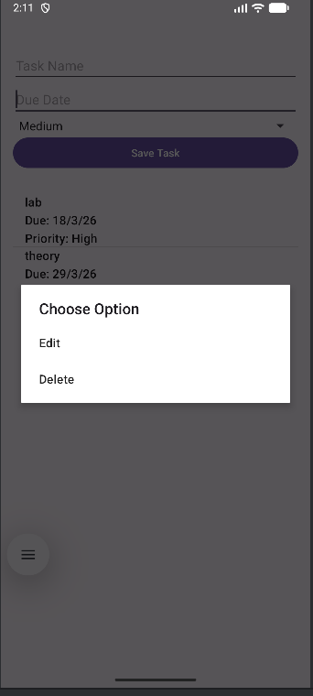
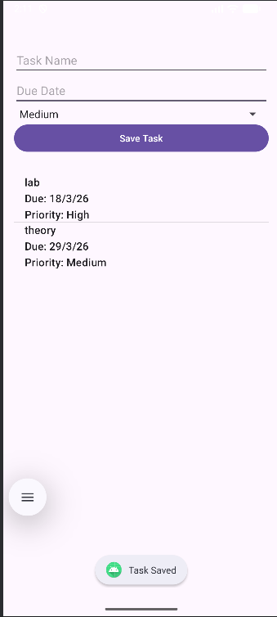
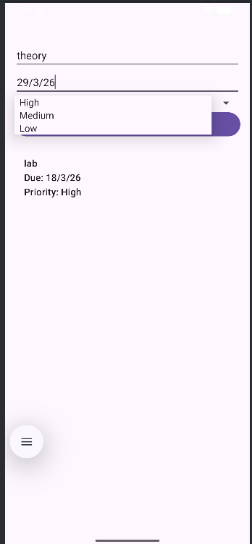
Q2. Write a program to add grocery items along with its cost into the database and display the total cost of all the item selected by the user. Items has to be displayed through spinner.

activity_main.xml
<?xml version="1.0" encoding="utf-8"?>
<LinearLayout
xmlns:android="http://schemas.android.com/apk/res/android"
android:layout_width="match_parent"
android:layout_height="match_parent"
android:gravity="center"
android:orientation="vertical"
android:padding="20dp">
<LinearLayout
android:layout_width="300dp"
android:layout_height="wrap_content"
android:orientation="vertical">
<EditText
android:id="@+id/etItemName"
android:layout_width="match_parent"
android:layout_height="wrap_content"
android:hint="Enter Grocery Item"/>
<EditText
android:id="@+id/etItemCost"
android:layout_width="match_parent"
android:layout_height="wrap_content"
android:hint="Enter Cost"
android:inputType="numberDecimal"
android:layout_marginTop="10dp"/>
<Button
android:id="@+id/btnAdd"
android:layout_width="match_parent"
android:layout_height="wrap_content"
android:text="Add Item"
android:layout_marginTop="10dp"/>
<Spinner
android:id="@+id/spinnerItems"
android:layout_width="match_parent"
android:layout_height="wrap_content"
android:layout_marginTop="15dp"/>
<Button
android:id="@+id/btnSelect"
android:layout_width="match_parent"
android:layout_height="wrap_content"
android:text="Add To Total"
android:layout_marginTop="10dp"/>
<TextView
android:id="@+id/tvTotal"
android:layout_width="match_parent"
android:layout_height="wrap_content"
android:text="Total: 0"
android:textSize="18sp"
android:gravity="center"
android:layout_marginTop="15dp"/>
</LinearLayout>
</LinearLayout>

MainActivity.java
package com.example.a2;
import android.os.Bundle;
import android.widget.ArrayAdapter;
import android.widget.Button;
import android.widget.EditText;
import android.widget.Spinner;
import android.widget.TextView;
import android.widget.Toast;
import androidx.appcompat.app.AppCompatActivity;
import java.util.ArrayList;
public class MainActivity extends AppCompatActivity {
EditText etItemName, etItemCost;
Button btnAdd, btnSelect;
Spinner spinner;
TextView tvTotal;
DBHelper dbHelper;
double total = 0;
@Override
protected void onCreate(Bundle savedInstanceState) {
super.onCreate(savedInstanceState);
setContentView(R.layout.activity_main);
etItemName = findViewById(R.id.etItemName);
etItemCost = findViewById(R.id.etItemCost);
btnAdd = findViewById(R.id.btnAdd);
btnSelect = findViewById(R.id.btnSelect);
spinner = findViewById(R.id.spinnerItems);
tvTotal = findViewById(R.id.tvTotal);
dbHelper = new DBHelper(this);
btnAdd.setOnClickListener(v -> {
String name = etItemName.getText().toString();
String costStr = etItemCost.getText().toString();
if (name.isEmpty() || costStr.isEmpty()) {
Toast.makeText(this, "Enter all fields", Toast.LENGTH_SHORT).show();
return;
}
double cost = Double.parseDouble(costStr);
if (dbHelper.insertItem(name, cost)) {
Toast.makeText(this, "Item Added", Toast.LENGTH_SHORT).show();
loadSpinner();
etItemName.setText("");
etItemCost.setText("");
}
});
btnSelect.setOnClickListener(v -> {
String selectedItem = spinner.getSelectedItem().toString();
double cost = dbHelper.getItemCost(selectedItem);
total += cost;
tvTotal.setText("Total: " + total);
});
loadSpinner();
}
private void loadSpinner() {
ArrayList<String> items = dbHelper.getAllItems();
ArrayAdapter<String> adapter = new ArrayAdapter<>(
this,
android.R.layout.simple_spinner_dropdown_item,
items
);
spinner.setAdapter(adapter);
}
}
DBHelper.java
package com.example.a2;
import android.content.ContentValues;
import android.content.Context;
import android.database.Cursor;
import android.database.sqlite.SQLiteDatabase;
import android.database.sqlite.SQLiteOpenHelper;
import java.util.ArrayList;
public class DBHelper extends SQLiteOpenHelper {
public DBHelper(Context context) {
super(context, "GroceryDB", null, 1);
}
@Override
public void onCreate(SQLiteDatabase db) {
db.execSQL("CREATE TABLE grocery(id INTEGER PRIMARY KEY AUTOINCREMENT, name TEXT, cost REAL)");
}
@Override
public void onUpgrade(SQLiteDatabase db, int oldVersion, int newVersion) {
db.execSQL("DROP TABLE IF EXISTS grocery");
onCreate(db);
}
public boolean insertItem(String name, double cost) {
SQLiteDatabase db = this.getWritableDatabase();
ContentValues values = new ContentValues();
values.put("name", name);
values.put("cost", cost);
long result = db.insert("grocery", null, values);
return result != -1;
}
public ArrayList<String> getAllItems() {
ArrayList<String> list = new ArrayList<>();
SQLiteDatabase db = this.getReadableDatabase();
Cursor cursor = db.rawQuery("SELECT * FROM grocery", null);
while (cursor.moveToNext()) {
list.add(cursor.getString(1));
}
cursor.close();
return list;
}
public double getItemCost(String name) {
SQLiteDatabase db = this.getReadableDatabase();
Cursor cursor = db.rawQuery("SELECT cost FROM grocery WHERE name=?", new String[]{name});
double cost = 0;
if (cursor.moveToFirst()) {
cost = cursor.getDouble(0);
}
cursor.close();
return cost;
}
}

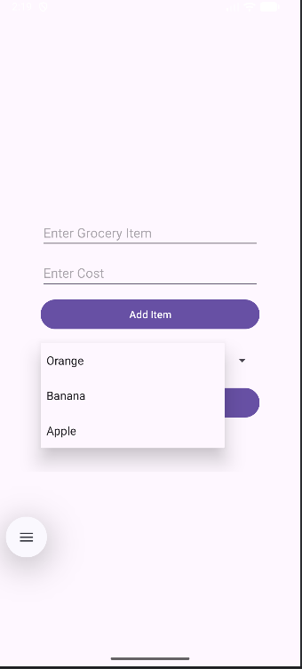
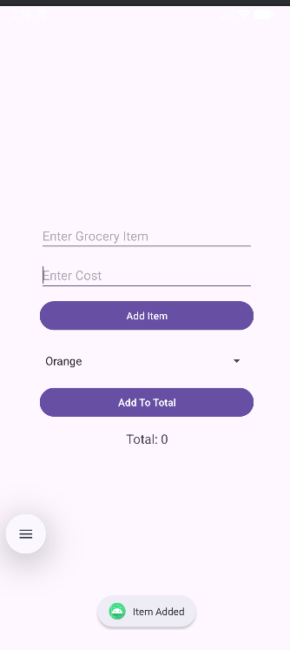
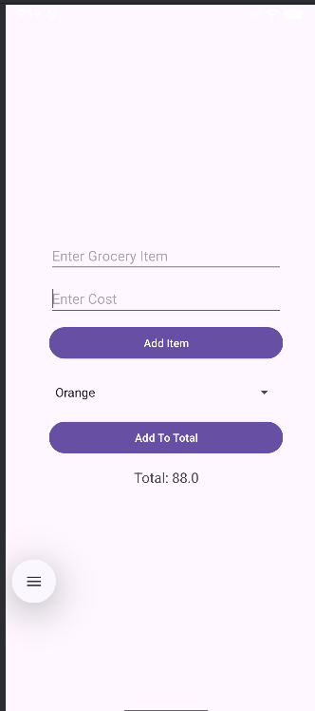

  - Q3. Create an application “Movie Review” to create a movie review to do the following: User can write a movie review by stating movie name, year,giving points ranging from 1-5 and save details in a database.
  - User can view the movie review for which review are already defined .Movie names has to be displayed using listview,and the selected movie’s details should be displayed in a table.

activity_main.xml
<?xml version="1.0" encoding="utf-8"?>
<ScrollView xmlns:android="http://schemas.android.com/apk/res/android"
android:layout_width="match_parent"
android:layout_height="match_parent">
<LinearLayout
android:layout_width="match_parent"
android:layout_height="match_parent"
android:gravity="center"
android:orientation="vertical"
android:padding="20dp">
<LinearLayout
android:layout_width="320dp"
android:layout_height="wrap_content"
android:orientation="vertical">
<EditText
android:id="@+id/etMovieName"
android:layout_width="match_parent"
android:layout_height="wrap_content"
android:hint="Movie Name"/>
<EditText
android:id="@+id/etYear"
android:layout_width="match_parent"
android:layout_height="wrap_content"
android:hint="Year"
android:inputType="number"
android:layout_marginTop="10dp"/>
<Spinner
android:id="@+id/spinnerRating"
android:layout_width="match_parent"
android:layout_height="wrap_content"
android:layout_marginTop="10dp"/>
<Button
android:id="@+id/btnSave"
android:layout_width="match_parent"
android:layout_height="wrap_content"
android:text="Save Review"
android:layout_marginTop="10dp"/>
<TextView
android:layout_width="match_parent"
android:layout_height="wrap_content"
android:text="Saved Movies"
android:textSize="18sp"
android:gravity="center"
android:layout_marginTop="20dp"/>
<ListView
android:id="@+id/listViewMovies"
android:layout_width="match_parent"
android:layout_height="200dp"
android:layout_marginTop="10dp"/>
<TableLayout
android:id="@+id/tableDetails"
android:layout_width="match_parent"
android:layout_height="wrap_content"
android:layout_marginTop="20dp"
android:stretchColumns="1"/>
</LinearLayout>
</LinearLayout>
</ScrollView>

MainActivity.java
package com.example.a3;
import android.database.Cursor;
import android.os.Bundle;
import android.view.View;
import android.widget.*;
import androidx.appcompat.app.AppCompatActivity;
import java.util.ArrayList;
public class MainActivity extends AppCompatActivity {
EditText etMovieName, etYear;
Spinner spinnerRating;
Button btnSave;
ListView listView;
TableLayout tableLayout;
DBHelper dbHelper;
@Override
protected void onCreate(Bundle savedInstanceState) {
super.onCreate(savedInstanceState);
setContentView(R.layout.activity_main);
etMovieName = findViewById(R.id.etMovieName);
etYear = findViewById(R.id.etYear);
spinnerRating = findViewById(R.id.spinnerRating);
btnSave = findViewById(R.id.btnSave);
listView = findViewById(R.id.listViewMovies);
tableLayout = findViewById(R.id.tableDetails);
dbHelper = new DBHelper(this);
// Rating Spinner
ArrayAdapter<String> ratingAdapter = new ArrayAdapter<>(
this,
android.R.layout.simple_spinner_dropdown_item,
new String[]{"1", "2", "3", "4", "5"});
spinnerRating.setAdapter(ratingAdapter);
btnSave.setOnClickListener(v -> saveMovie());
loadMovies();
listView.setOnItemClickListener((parent, view, position, id) -> {
String selectedMovie = parent.getItemAtPosition(position).toString();
showMovieDetails(selectedMovie);
});
}
private void saveMovie() {
String name = etMovieName.getText().toString();
String yearStr = etYear.getText().toString();
int rating = Integer.parseInt(spinnerRating.getSelectedItem().toString());
if (name.isEmpty() || yearStr.isEmpty()) {
Toast.makeText(this, "Fill all fields", Toast.LENGTH_SHORT).show();
return;
}
int year = Integer.parseInt(yearStr);
if (dbHelper.insertMovie(name, year, rating)) {
Toast.makeText(this, "Review Saved", Toast.LENGTH_SHORT).show();
loadMovies();
etMovieName.setText("");
etYear.setText("");
}
}
private void loadMovies() {
ArrayList<String> movies = dbHelper.getAllMovies();
ArrayAdapter<String> adapter = new ArrayAdapter<>(
this,
android.R.layout.simple_list_item_1,
movies);
listView.setAdapter(adapter);
}
private void showMovieDetails(String name) {
tableLayout.removeAllViews();
Cursor cursor = dbHelper.getMovieDetails(name);
if (cursor.moveToFirst()) {
addRow("Movie Name", cursor.getString(1));
addRow("Year", cursor.getString(2));
addRow("Rating", cursor.getString(3) + " / 5");
}
cursor.close();
}
private void addRow(String key, String value) {
TableRow row = new TableRow(this);
TextView tvKey = new TextView(this);
tvKey.setText(key);
tvKey.setPadding(10,10,10,10);
TextView tvValue = new TextView(this);
tvValue.setText(value);
tvValue.setPadding(10,10,10,10);
row.addView(tvKey);
row.addView(tvValue);
tableLayout.addView(row);
}
}
DBHelper.java
package com.example.a3;
import android.content.ContentValues;
import android.content.Context;
import android.database.Cursor;
import android.database.sqlite.SQLiteDatabase;
import android.database.sqlite.SQLiteOpenHelper;
import java.util.ArrayList;
public class DBHelper extends SQLiteOpenHelper {
public DBHelper(Context context) {
super(context, "MovieDB", null, 1);
}
@Override
public void onCreate(SQLiteDatabase db) {
db.execSQL("CREATE TABLE movies(id INTEGER PRIMARY KEY AUTOINCREMENT, name TEXT, year INTEGER, rating INTEGER)");
}
@Override
public void onUpgrade(SQLiteDatabase db, int oldVersion, int newVersion) {
db.execSQL("DROP TABLE IF EXISTS movies");
onCreate(db);
}
public boolean insertMovie(String name, int year, int rating) {
SQLiteDatabase db = this.getWritableDatabase();
ContentValues values = new ContentValues();
values.put("name", name);
values.put("year", year);
values.put("rating", rating);
long result = db.insert("movies", null, values);
return result != -1;
}
public ArrayList<String> getAllMovies() {
ArrayList<String> list = new ArrayList<>();
SQLiteDatabase db = this.getReadableDatabase();
Cursor cursor = db.rawQuery("SELECT name FROM movies", null);
while (cursor.moveToNext()) {
list.add(cursor.getString(0));
}
cursor.close();
return list;
}
public Cursor getMovieDetails(String name) {
SQLiteDatabase db = this.getReadableDatabase();
return db.rawQuery("SELECT * FROM movies WHERE name=?", new String[]{name});
}
}

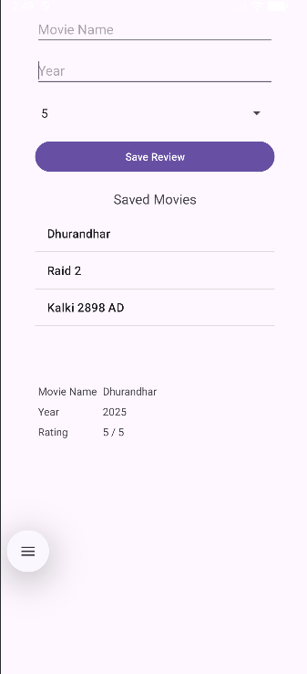
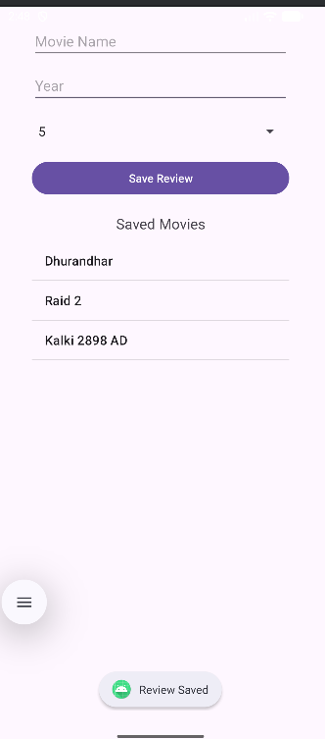
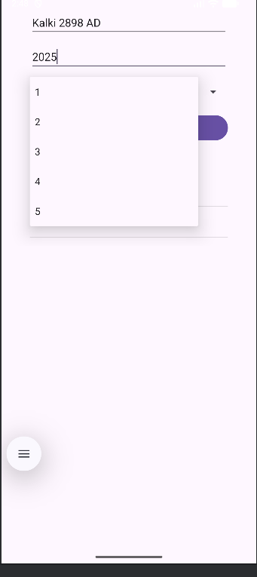

  - Q4. Make use of SQLite browser to view the database ,tables created.Modify the tables and upload the same into your project and view the modified data through your app.

activity_main.xml
<?xml version="1.0" encoding="utf-8"?>
<androidx.constraintlayout.widget.ConstraintLayout xmlns:android="http://schemas.android.com/apk/res/android"
xmlns:app="http://schemas.android.com/apk/res-auto"
android:layout_width="match_parent"
android:layout_height="match_parent">
<TextView
android:id="@+id/textView"
android:layout_width="wrap_content"
android:layout_height="wrap_content"
android:text="Movies"
android:textSize="22sp"
app:layout_constraintTop_toTopOf="parent"
app:layout_constraintBottom_toBottomOf="parent"
app:layout_constraintStart_toStartOf="parent"
app:layout_constraintEnd_toEndOf="parent"/>
</androidx.constraintlayout.widget.ConstraintLayout>

MainActivity.java
package com.example.a4;
import android.database.Cursor;
import android.database.sqlite.SQLiteDatabase;
import android.os.Bundle;
import android.widget.TextView;
import androidx.appcompat.app.AppCompatActivity;
public class MainActivity extends AppCompatActivity {
TextView tv;
@Override
protected void onCreate(Bundle savedInstanceState) {
super.onCreate(savedInstanceState);
setContentView(R.layout.activity_main);
tv = findViewById(R.id.textView);
DBHelper dbHelper = new DBHelper(this);
SQLiteDatabase db = dbHelper.getReadableDatabase();
Cursor cursor = db.rawQuery("SELECT * FROM movies", null);
String result = "";
if(cursor.moveToFirst()){
do{
result += cursor.getInt(0) + " - " + cursor.getString(1) + "\n";
}while(cursor.moveToNext());
}
tv.setText(result);
}
}

DBHelper.java
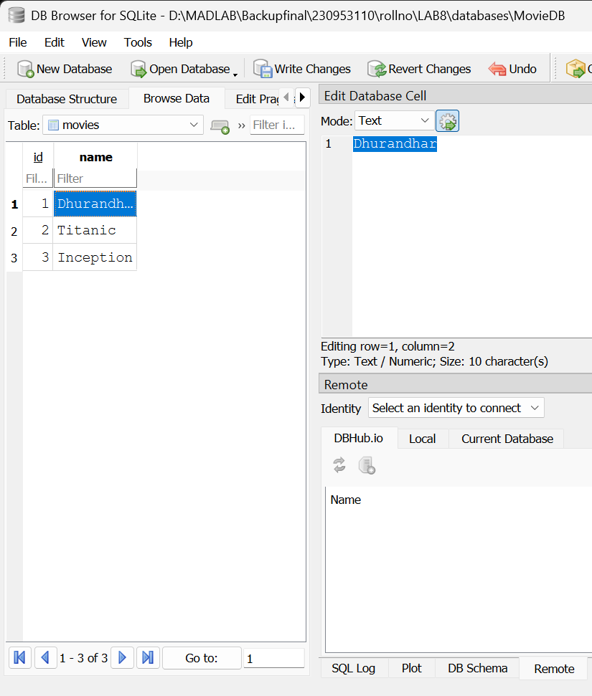
package com.example.a4;
import android.content.Context;
import android.database.sqlite.SQLiteDatabase;
import android.database.sqlite.SQLiteOpenHelper;
public class DBHelper extends SQLiteOpenHelper {
public DBHelper(Context context) {
super(context, "MovieDB", null, 1);
}
@Override
public void onCreate(SQLiteDatabase db) {
db.execSQL("CREATE TABLE movies(id INTEGER PRIMARY KEY, name TEXT)");
db.execSQL("INSERT INTO movies VALUES(1,'Avatar')");
db.execSQL("INSERT INTO movies VALUES(2,'Titanic')");
db.execSQL("INSERT INTO movies VALUES(3,'Inception')");
}
@Override
public void onUpgrade(SQLiteDatabase db, int oldVersion, int newVersion) {
}
}

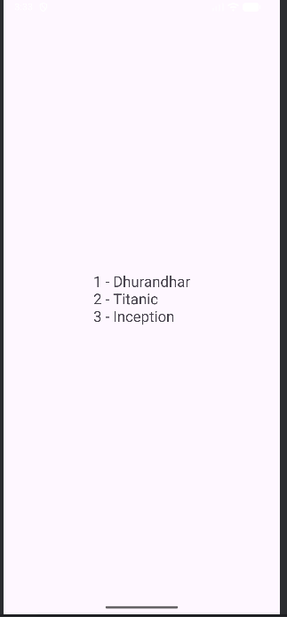
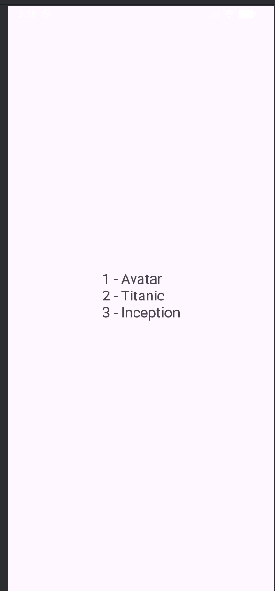

Q5. Demonstrates the use of the Shared Preferences through an android application which displays a screen with some text fields. Save the value when the application is closed and brought back when it is opened again.

activity_main.xml
<?xml version="1.0" encoding="utf-8"?>
<LinearLayout
xmlns:android="http://schemas.android.com/apk/res/android"
android:layout_width="match_parent"
android:layout_height="match_parent"
android:orientation="vertical"
android:gravity="center"
android:padding="20dp">
<LinearLayout
android:layout_width="300dp"
android:layout_height="wrap_content"
android:orientation="vertical">
<EditText
android:id="@+id/etName"
android:layout_width="match_parent"
android:layout_height="wrap_content"
android:hint="Enter Name"/>
<EditText
android:id="@+id/etEmail"
android:layout_width="match_parent"
android:layout_height="wrap_content"
android:hint="Enter Email"
android:layout_marginTop="10dp"/>
<EditText
android:id="@+id/etPhone"
android:layout_width="match_parent"
android:layout_height="wrap_content"
android:hint="Enter Phone"
android:inputType="phone"
android:layout_marginTop="10dp"/>
<TextView
android:layout_width="match_parent"
android:layout_height="wrap_content"
android:text="(Close and reopen app to see saved data)"
android:textSize="12sp"
android:layout_marginTop="15dp"
android:gravity="center"/>
</LinearLayout>
</LinearLayout>

MainActivity.java
package com.example.a5;
import android.content.SharedPreferences;
import android.os.Bundle;
import android.widget.EditText;
import androidx.appcompat.app.AppCompatActivity;
public class MainActivity extends AppCompatActivity {
EditText etName, etEmail, etPhone;
SharedPreferences sharedPreferences;
@Override
protected void onCreate(Bundle savedInstanceState) {
super.onCreate(savedInstanceState);
setContentView(R.layout.activity_main);
etName = findViewById(R.id.etName);
etEmail = findViewById(R.id.etEmail);
etPhone = findViewById(R.id.etPhone);
sharedPreferences = getSharedPreferences("MyPrefs", MODE_PRIVATE);
// Load saved data
loadData();
}
@Override
protected void onPause() {
super.onPause();
saveData();
}
private void saveData() {
SharedPreferences.Editor editor = sharedPreferences.edit();
editor.putString("name", etName.getText().toString());
editor.putString("email", etEmail.getText().toString());
editor.putString("phone", etPhone.getText().toString());
editor.apply(); // save changes
}
private void loadData() {
String name = sharedPreferences.getString("name", "");
String email = sharedPreferences.getString("email", "");
String phone = sharedPreferences.getString("phone", "");
etName.setText(name);
etEmail.setText(email);
etPhone.setText(phone);
}
}

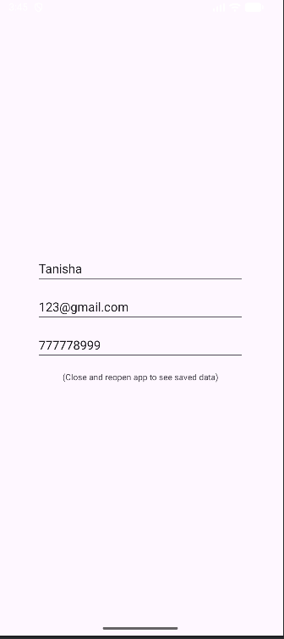
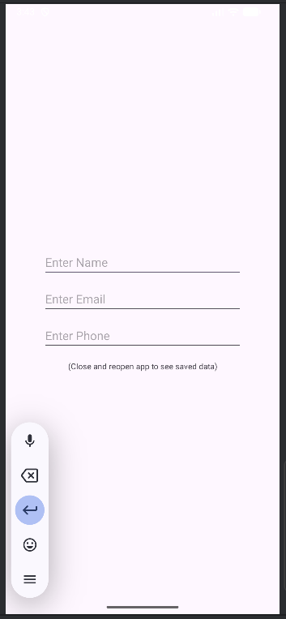

Submitted By: Tanisha Mathur
Reg. No.: 230953110
CCE: B, Roll No.: 17

